Incentives and Risk-Taking in Delegated Portfolio Management: A Contracting Approach

Juan F. Imbet
Université Paris Dauphine
Igor Yelnik
Alphidence Capital Ltd
Frank J. Fabozzi
Johns Hopkins University
2026-04-08
Abstract
This paper studies the agency conflicts in delegated portfolio management. We develop a tractable principal-agent model in which fund managers have incentives to load on high volatility investments as a convex flow-performance relation increases their upside. This risk-seeking behavior is beneficial to managers, but not to investors. We derive the optimal incentive-compatible management fee that implements the desired volatility target. Our paper provides a tractable framework with the aim to study this type of agency frictions in delegated portfolio management, and provide guidance on its implementation. We demonstrate that a simple linear approximation makes the contract between the manager and the investor easy to communicate and implement as a “pay for risk, not luck” framework.
Keywords: delegated portfolio management; flow–performance convexity; incentive contracts; risk shifting
JEL Codes: G11; G23; D82

1 Introduction
Global assets under management have reached unprecedented levels, exceeding USD 128 trillion in 2024, with a substantial share allocated to delegated investment vehicles such as mutual funds, hedge funds, and institutional mandates. In these settings, investors delegate portfolio decisions to professional managers while retaining only limited control over the underlying investment process. Unlike direct ownership of firms, where investors may exercise governance rights, delegated portfolio management typically involves contracts that specify outcomes rather than actions. As a result, investors have little influence over how risk is chosen or implemented, and managerial decisions are only imperfectly observable (Bebchuk et al. 2017).
This institutional structure creates scope for agency frictions. Managers are compensated primarily through fees linked to assets under management, while investors care about risk-adjusted returns as well. Empirical evidence further indicates that fees are not necessarily aligned with performance, as poorly performing funds may charge higher fees than better-performing peers (Gil-Bazo and Ruiz-Verdú 2008). At the same time, investor capital flows respond asymmetrically to performance. A large literature documents that inflows increase strongly with good performance, particularly in the upper tail of the return distribution, while outflows following poor performance are more gradual (Ippolito 1992; Chevalier and Ellison 1997; Sirri and Tufano 1998). This convex flow–performance relationship implies that the mapping from performance to assets under management is nonlinear.
The interaction between fee structures and convex flows has important implications for managerial incentives. Because fees are proportional to assets under management, and assets respond disproportionately to strong performance, the manager’s payoff becomes convex in returns. This convexity resembles the payoff of a financial option. As in standard option pricing, higher volatility increases the probability of extreme positive outcomes, which are disproportionately rewarded through inflows. Consequently, even when expected returns per unit of risk are unchanged, a manager can increase expected compensation by raising portfolio volatility (Brown et al. 1996). This creates a divergence between the manager’s privately optimal choice of risk and the level of risk preferred by investors.
The central objective of this paper is to characterize how compensation contracts can be designed to mitigate this risk-shifting incentive. We develop a tractable principal–agent model of delegated portfolio management in which the manager chooses portfolio volatility and investors allocate capital based on realized performance. The model incorporates a convex flow–performance relationship and a fee structure tied to assets under management. Within this framework, we derive the incentive-compatible contract that implements a target level of portfolio volatility chosen by the investor.
Our main result is that, under mild conditions, there exists a unique fee schedule that aligns the manager’s incentives with the investor’s desired risk target. This incentive-compatible fee can be expressed as a function of the target volatility. Furthermore, we show that over empirically relevant ranges, this relationship can be well approximated by a simple affine function. This yields a contract that can be interpreted as compensating the manager for the level of risk undertaken rather than for realized outcomes. We refer to this structure as a “pay for risk, not luck” framework. A numerical calibration based on empirical parameter values demonstrates that the linear approximation closely tracks the optimal contract and provides a practical representation of the underlying incentive structure.
This paper contributes to the literature on agency problems in delegated portfolio management. In classic principal–agent models, investors contract on observable outcomes because effort and information acquisition are not directly observable (Holmström 1979; Admati and Pfleiderer 1997). This gives rise to well-known distortions, including underinvestment in costly effort, short-horizon behavior around evaluation dates, and actions that increase private benefits at the expense of investor welfare (Jensen and Meckling 1976; Musto 1999; Carhart et al. 2002). Our contribution is to highlight a distinct channel through which agency frictions arise. Specifically, we show that the interaction between convex investor flows and standard fee structures creates an endogenous incentive to increase portfolio volatility, even in the absence of explicit performance fees.
Relative to existing work on incentive contracts in asset management (Starks 1987; Admati and Pfleiderer 1997; Holmström and Milgrom 1987), our framework provides a tractable characterization of how contracts can be designed to control risk-taking directly. Rather than focusing solely on performance-based compensation, we derive a contract that implements a desired risk level as an equilibrium outcome. This approach shifts the emphasis from ex post evaluation of performance to ex ante alignment of incentives.
The remainder of the paper is organized as follows. Section 2 presents the model. Section 3 characterizes the manager’s problem and the incentive to increase volatility. Section 4 derives the incentive-compatible contract. Section 5 analyzes the investor’s optimal choice of volatility. Section 6 provides a calibration

2 The Model
We now introduce a tractable model of delegated portfolio management that captures the interaction between portfolio risk, investor flows, and fee-based compensation. The framework is designed to isolate the mechanism through which convex flow–performance relationships affect managerial incentives and to provide a setting in which incentive-compatible contracts can be characterized analytically.

2.1 Setup
Consider a two-period economy $t∈\{0,1\}$ populated by a representative fund and a continuum of investors. The fund generates excess returns over a risk–free rate with a constant Sharpe ratio as follows:
$$r-r_{f} = S σ + σ ϵ, ϵ∼N(0,1), σ>0,$$
where $S$ is the Sharpe Ratio of the fund, assumed to be common knowledge between manager and investors. The volatility $σ$ is a decision variable of the asset manager. Within a standard asset pricing interpretation, σ can be viewed as scaling exposure to a strategy with constant Sharpe ratio, for example through leverage. Intuitively, $σ$ is the risk knob: raising it increases expected excess return, but it also increases the dispersion of outcomes around that mean.
With this setup, expected excess returns increase linearly with volatility: $E\left[r-r_{f}\right]=Sσ,and V\left[r-r_{f}\right]=σ^{2}.$ Thus, taking more risk by increasing $σ$ raises average performance but also increases uncertainty, and returns can be written as $r=r_{f}+σ(S+ϵ)$.
Both current and potential investors exhibit a convex response to the fund’s positive performance. They invest disproportionately more during periods of good performance and redeem during bad times.
We assume a reduced form relation between past performance and fund flows. Let flows to the fund after current and potential investors observe $r$ be
$$\begin{matrix}F(r)=\left\{\begin{matrix}f_{1}(r-r_{f})+f_{2}(r-r_{f})^{2} & \text{if }r≥r_{f}, \\ f_{1}(r-r_{f}) & \text{if }r<r_{f},\end{matrix}\right.\end{matrix}$$
with $f_{1},f_{2}≥0$. This flow function captures the asymmetric response of investors to performance: when returns fall below the risk–free rate, investors withdraw capital at a constant linear rate, whereas once returns exceed $r_{f}$, inflows become convex in performance. The quadratic term amplifies flows after good outcomes, reflecting performance chasing in the right tail (see Figure 1).
Assets under management (AUM) at the end of the period evolve based on the return of the fund and the new net flows.
$$A = A_{0}(1+r) + F(r),$$
so AUM is the sum of a pure performance component (initial assets grown by the return) and a scale component coming from investor reallocations after observing performance.
We model the management fee at rate $ϕ$ as applied to end-of-period AUM. In practice, mutual funds typically charge based on the beginning-of-period or average AUM. In this single–period setting, charging on end–of–period or average AUM is equivalent up to first order in $ϕ$; Appendix E shows the equivalence and how to translate between conventions. The investor’s net return per unit of initial wealth is then
 | rnet = r - ϕ (1+r) = (1-ϕ) r-ϕ. | (1)

This relation shows that management fees reduce the investor’s payoff in two ways: they scale down the gross return and subtract the fee rate.
For small $ϕ$, it is common to use an approximation: $r^{\text{net}}≈r-ϕ$. Equation (1) is exact and we will use it across the paper. Although fee structures vary across the asset management industry, the linear specification adopted here provides a tractable benchmark and can be extended to alternative compensation schemes.
If a performance fee $ψ$ is charged on positive excess performance, a reduced–form net return is
$$r^{\text{net}} = r-ϕ(1+r)-ψ (r-r_{f})^{+}.$$
Under this specification, the performance fee applies only when the fund beats the risk–free rate. Relative to a pure management fee, this shifts more compensation into upside states. Since the manager’s incentives already tilt toward the right tail when flows are convex, performance fees can materially affect the equilibrium. In the extension with performance fees, the economic mechanism is unchanged, but closed-form expressions become less transparent, so we rely on numerical solutions and the corresponding fee-volatility relationships.
This specification ignores high–water marks (HWM) that are common in alternative investment funds. Omitting HWM slightly overstates the right–tail convexity in manager pay. Appendix F sketches how to incorporate HWM in our normal–returns setting.
The manager has mean variance preferences with a constant absolute risk aversion $η>0$ over fee revenue $ϕA$:
$$U_{M} = ϕE[A] - \frac{ηϕ^{2}}{2} V[A],$$
so the manager values higher expected fee income but dislikes fluctuations in AUM because they make fee income risky.
Investors have mean-variance preferences over net returns with a risk aversion captured by $γ>0$:
$$U_{I}(σ,ϕ) = E[r^{\text{net}}] - \frac{γ}{2} V[r^{\text{net}}].$$
Using(1), a convenient representation is
$$U_{I}(σ,ϕ) = (1-ϕ) (r_{f}+Sσ)-ϕ - \frac{γ}{2} (1-ϕ)^{2} σ^{2}.$$
This makes the investor’s trade-off transparent: higher volatility $σ$ raises expected return when the fund has skill ($S>0$), but it raises risk quadratically; fees lower the investor’s mean payoff and rescale effective exposure.

2.2 Manager’s problem and incentives
The manager controls volatility σ and, through σ, affects both the fund’s return distribution and investor flows. This creates a central incentive mechanism in the model: when flows are convex in good states, taking more risk increases the likelihood and magnitude of extreme positive outcomes, and such outcomes attract disproportionately large inflows. Since fees are proportional to AUM, the manager benefits from this right-tail scaling.
To isolate the mechanism, it is helpful to think of end-of-period AUM as having a deterministic base plus a component that increases with realized performance and flows. With skill ($S>0$), raising $σ$ increases expected performance, and thus expected AUM. With convex flows ($f_{2}>0$), raising $σ$ does more than that: it increases the weight on upside states where inflows accelerate, so expected fee revenue becomes especially sensitive to volatility. At the same time, AUM becomes riskier when $σ$ increases. The exact mean and variance expressions (and their derivatives with respect to σ) are summarized below, with full derivations provided in Appendix B.
Let $K:=A_{0}+f_{1}$, $X:=S+Z$, and $I:=1_{\left\{X ≥ 0\right\}}$. Using $r=r_{f}+σX$, end-of-period AUM can be written as $A=A_{0}(1+r_{f})+KσX+f_{2}σ^{2}X^{2}I.$
Expected AUM is given by $E[A]=A_{0}(1+r_{f})+KSσ+f_{2}σ^{2}C_{1},$ where $C_{1}:=(S^{2}+1)Φ(S)+Sϕ(S).$ The variance of AUM is $Var(A)=K^{2}σ^{2}+2Kf_{2}σ^{3}C_{2}+f_{2}^{2}σ^{4}C_{3},$ where $C_{2}:=Cov(X,X^{2}I)$and $C_{3}:=Var(X^{2}I)$, with closed-form expressions provided in Appendix B. Differentiating with respect to $σ$,
$$\frac{∂}{∂σ}E[A]=KS+2f_{2}σC_{1}, \\ \frac{∂}{∂σ}Var(A)=2K^{2}σ+Δ_{\text{quad}}(S,f_{2};σ),$$
where $Δ_{\text{quad}}(S,f_{2};σ)$collects higher-order terms defined in Appendix B.
The manager chooses $σ$ to maximize
$$U_{M}(σ,ϕ) = ϕ E[A]-\frac{ηϕ^{2}}{2} V[A].$$
The resulting best response $σ^{*}(ϕ)$ is characterized in Appendix 9. The comparative statistics are intuitive: higher risk aversion $η$ reduces risk-taking because the manager dislikes fee revenue volatility; higher convexity $f_{2}$ increases risk-taking because convex flows make upside states more valuable.
This characterization highlights the core agency friction in the model: in the absence of contractual discipline, the manager’s privately optimal volatility generally exceeds the level preferred by investors.
For implementation, a simple and accurate approximation to the incentive–compatible schedule is to set the management fee approximately linear in the desired volatility target $σ_{d}$:
$$ϕ(σ_{d}) ≈ α + β σ_{d},$$
This affine approximation provides a tractable representation of the incentive-compatible contract derived below. It implies that, over the relevant range of risk targets, one can treat the incentive-compatible fee as a linear function of the desired volatility. In practice, $α$ plays the role of a base fee level, while $β$ governs how strongly fees adjust when the investor raises or lowers the volatility target. In the model, $α$ and $β$ can be obtained by locally linearizing the exact incentive–compatible fee around a reference volatility (Appendix 10).

2.3 Incentive compatibility: Implementing a target $σ_{d}$
Our goal is to align the interests of the manager and the investor by designing a contract that implements a desired level of risk. Let $σ_{d}$ be the investor’s desired volatility target. An incentive-compatible (IC) fee $ϕ(σ_{d})$ must make the manager willing to choose exactly $σ_{d}$.
The incentive compatibility condition has a simple economic form: at the target, the manager’s marginal benefit of raising volatility (through higher expected assets under management and associated flows) must be exactly offset by the marginal cost (through higher AUM risk). This pins down a unique fee level as a function of the target, under mild regularity conditions. The exact expression and existence and uniqueness conditions are summarized below, with full derivations provided in Appendix C, and 2 visualizes the mapping $σ_{d}↦ϕ(σ_{d})$.
The manager solves
$$\underset{σ}{max⁡} U_{M}(σ,ϕ)=ϕE[A]-\frac{ηϕ^{2}}{2}Var(A),$$
which yields the first-order condition
$$ϕ\frac{∂}{∂σ}E[A]-ηϕ^{2}\frac{∂}{∂σ}Var(A)=0.$$
For any target volatility $σ_{d}>0$, the incentive-compatible fee that induces the manager to choose σd is given by
$$ϕ(σ_{d})=\frac{{\frac{∂}{∂σ}E[A]∣}_{σ_{d}}}{η{\frac{∂}{∂σ}Var(A)∣}_{σ_{d}}}.$$
Using the expressions from Section 2.2, this can be written as
$$ϕ(σ_{d})=\frac{KS+2f_{2}σ_{d}C_{1}}{η\left(2K^{2}σ_{d}+Δ_{\text{quad}}(S,f_{2};σ_{d})\right)}.$$
This mapping is central to the analysis, as it translates a desired risk policy into an implementable compensation scheme.
The implications of this mapping for equilibrium contract design are analyzed in the next section.

3 Contract design: Investor’s problem
Building on the incentive-compatible mapping derived in Section 2, the main comparative statistics follow directly from the mechanism. Stronger flow convexity f₂ makes volatility more privately valuable to the manager because it increases upside scaling. Therefore, keeping the manager at the desired risk target requires a more restrictive contract, which in the model is reflected in a lower incentive-compatible management fee. Conversely, a more risk-averse manager (higher η) is naturally disciplined and can be offered a higher fee for a given target without inducing excessive risk shifting.
We now characterize the investor’s contract design problem, taking into account incentive compatibility and participation constraints. The investor chooses $σ_{d}$ (and thus $ϕ(σ_{d})$) to maximize its utility subject to IC and the manager’s participation constraint:.
$$\begin{aligned}\max_{σ_{d}>0} &U_{I}\left(σ_{d},ϕ\left(σ_{d}\right)\right) \\ \text{s.t.} &U_{M}\left(σ_{d},ϕ(σ_{d})\right)≥\overset{‾}{U}.\end{aligned}$$
Investor utility is given by $U_{I}(σ,ϕ)=(1-ϕ)(r_{f}+Sσ)-ϕ-\frac{γ}{2}(1-ϕ)^{2}σ^{2}.$ Differentiating the investor’s objective with respect to σd using the chain rule yields
$$\frac{dU_{I}}{dσ_{d}}=\frac{∂U_{I}}{∂σ}+\frac{∂U_{I}}{∂ϕ}⋅\frac{dϕ}{dσ_{d}}=0.$$

Proposition 2 (Optimal Volatility Target)
The equilibrium volatility target $σ_{d}^{*}$ is characterized by the first-order condition above. This condition reflects both the direct effect of volatility on expected returns and risk, and the indirect effect through the incentive-compatible fee schedule $ϕ(σ_{d})$. In general, the resulting equation is nonlinear in $σ_{d}$ and must be solved numerically.
The first term in the first-order condition captures the standard trade-off between expected return and risk: increasing volatility raises expected returns when the Sharpe ratio is positive but also increases variance. The second term reflects the contract adjustment required to sustain incentive compatibility. Because higher target volatility requires adjusting fees to discipline the manager, changes in $σ_{d}$ affect investor utility not only through portfolio risk but also through the share of returns retained after fees.
This program summarizes the investor’s contract design problem: choose a volatility target $σ_{d}$ that maximizes investor utility while guaranteeing that the manager is willing to participate and implement the target.
The conflict of interests is immediate in the model. The investor values higher $σ_{d}$ only to the extent that the fund’s skill (Sharpe ratio) compensates for additional risk, net of fees. The manager, in contrast, values higher $σ$ not only because it increases expected performance when $S>0$but also because it increases the probability and magnitude of inflows triggered by extreme positive outcomes. Incentive compatibility provides the key mechanism for alignment: for each target $σ_{d}$ there is a fee level that makes the manager choose exactly that risk, turning the investor’s policy choice into an implementable contract. The equilibrium target and the associated fee can be computed numerically; the first-order condition and the derivative of the fee schedule are given in Appendix D.
The structure of the optimal contract can be characterized through comparative statistics without solving the model numerically. First, an increase in flow convexity $f_{2}$ increases the option value of volatility for the manager, hence the IC fee $ϕ(σ_{d})$ must fall to keep incentives aligned (see Figure 4). For the investor, the contract becomes more “expensive” to adjust (large $|dϕ/dσ_{d}|$), pushing optimal $σ_{d}$ down. Second, an increase in the scale of the agency problem (higher initial AUM $A_{0}$ or the linear term $f_{1}$) amplifies AUM sensitivity to performance; as shown in Figure 5, both desired volatility $σ_{d}$ and the IC fee $ϕ(σ_{d})$ tend to decrease. Third, managerial skill (an increase in the Sharpe Ratio of the fund) improves the direct mean gain from risk taking; this tends to raise the optimal target, but the IC adjustment offsets part of the effect (see Figure 6). Finally, as illustrated in Figure 7, an increase in the investor’s risk aversion ($γ$) reduces $σ_{d}$; while a higher manager $η$ relaxes the need for fee discipline and allows a higher $ϕ$ for a given $σ_{d}$.
For implementation, the linear approximation introduced in Section 2.2 provides a simple way to communicate the contract as a base fee plus a marginal charge for volatility. Over the relevant range of volatility targets (e.g., 6–15% annualized), this affine rule closely tracks the exact IC fee (Appendix D).

4 Calibration
We calibrate the model to empirically grounded parameter values from the mutual fund and portfolio choice literature, ensuring that the implied equilibrium outcomes fall within empirically plausible ranges for delegated portfolio management.
We set investor risk aversion ($γ) equal to 5$as the baseline, with sensitivity analysis spanning $γ∈[2,10]$. These values are consistent with standard portfolio-choice calibrations (Campbell and Viceira 2002) and reflect the observed heterogeneity in risk preferences across investors (Guiso et al. 2018).
For the manager risk aversion over fee revenue ($η$), we use 3 as the baseline, allowing $η∈[1,8]$ in sensitivity exercises. If the manager is an individual portfolio manager with concentrated human capital, $η≥γ$ is plausible. If the manager represents a diversified fund family, $η≤γ$ can be reasonable. This baseline captures a manager who is moderately risk-averse to fee-income volatility, consistent with the presence of career concerns and compensation risk (Chevalier and Ellison 1997).
For the fund Sharpe ratio (S), we set $it at 0.35$ (annualized) for an active mutual fund baseline, consistent with the performance range documented for skilled managers net of transaction costs (Carhart 1997). We explore $S∈[0.10,1.00]$ in sensitivity analysis, with higher values (e.g., $S=0.60$) representing particularly skilled managers or hedge fund strategies (Fung and Hsieh 2004).
We use a risk-free rate ($r_{f}) of 3.70\%$ (annual), based on the 3-month U.S. Treasury constant maturity rate as of January 2026. Sensitivity analysis spans $r_{f}∈[0,5\%]$ to assess robustness across interest-rate regimes.
Empirical studies document strong convexity in the flow-performance relationship (which we denoted by f₁, f₂), whereby top-performing funds attract disproportionately large inflows (Sirri and Tufano 1998; Ferreira et al. 2012). To match realistic annual flow responses, we set f₁ at 1.5 and f₂ at 25, where excess returns are measured in decimal units. For example, a 5% excess return corresponds to 0.05. This parameterization implies that a fund with +5% excess return experiences flows of approximately +13.8% of AUM, while a fund with +10% excess return sees flows around +40%, capturing the strong convexity observed in empirical flow–performance relationships. We explore f₁ ∈ [0.5, 3] and f₂ ∈ [5, 60] to assess sensitivity to flow convexity.
$cess return sees flows around plus 40\%,$capturing the strong convexity observed in empirical flow–performance relationships. We explore $f_{1}∈[0.5,3]$ and $f_{2}∈[5,60]$ to assess sensitivity to flow convexity.
We normalize the initial AUM $A_{0} at 1$ since the problem is scale-invariant with proportional fees and homogeneous preferences. If one were to incorporate decreasing returns to scale or capacity constraints, AUM scale would interact with fund performance (Berk and Green 2004), but we abstract from such effects in our baseline specification.

With these parameters, the model produces optimal volatility targets $σ_{d}^{*}∈[8\%,20\%]$ (annualized), which are consistent with observed volatility levels for actively managed equity mutual funds. For reference, Barras et al. (2010) use a monthly market-return standard deviation of approximately 4.6%, corresponding to roughly 16% annualized. Individual fund volatilities can be higher or lower depending on style and leverage, but our target range aligns with typical volatilities of delegated equity portfolios.

5 Numerical illustration
We now illustrate the quantitative implications of the model using the calibrated parameters described in Section 4. This section illustrates the model using the calibrated baseline parameters from Section 4: $S=0.35$, $r_{f}=3.70\%$, investor risk aversion $γ=5$, manager risk aversion $η=3$, scale parameters $A_{0}=1$ (normalized) and $f_{1}=1.5$, and convexity $f_{2}=25$.
Figure 1 shows the key economic input to the model: flows accelerate after good outcomes. This is the core agency friction because it makes upside states disproportionately valuable to the manager. Figure 2 shows the IC mapping implied by the model: for each target volatility $σ_{d}$, there is a fee level that makes the manager willing to choose it. Higher convexity shifts the schedule, reflecting stronger incentives to over-risk when performance chasing is more pronounced. Figure 3 shows the equilibrium implication: as convexity increases, the investor optimally targets a lower volatility because sustaining a high target becomes more costly in terms of incentive alignment.
Finally, Figure 8 assesses the quality of the affine approximation introduced in Section 2.2 across different convexity levels. Notably, the average absolute error remains almost unchanged at around 0.1% as the convexity parameter $f_{2}$ varies, demonstrating that the approximation quality is robust to more convex sensitivities of flows to performance. This stability confirms that the linear contract is an accurate and practical representation of the optimal incentive-compatible fee schedule across the empirically relevant range.

These results highlight how the model translates observable features of investor behavior into implications for contract design. For both investors and managers, these relationships provide a transparent mapping from a volatility target to a corresponding fee level, sustaining incentive alignment under realistic market conditions.

6 Conclusion
This paper develops a tractable principal–agent framework to study agency conflicts in delegated portfolio management. In the model, performance chasing generates an option-like payoff for managers, which tilts their incentives toward higher volatility relative to what investors would choose.
The central contribution of the paper is to characterize how compensation contracts can be designed to implement a desired level of portfolio risk. The main practical output is a fee schedule that implements a target volatility: for each risk target, there exists a management fee level that makes the manager willing to choose that level of risk rather than increase volatility to benefit from convex flow dynamics.
The main practical output is a fee schedule that implements a target volatility: for each risk target, there exists a management fee level that makes the manager willing to choose that level of risk rather than increase volatility to benefit from convex flow dynamics.
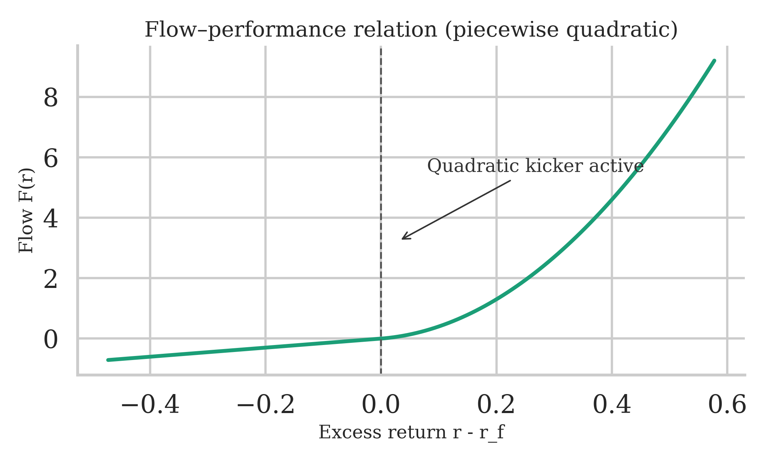
Note: Calibrated baseline parameters: $S=0.35$, $r_{f}=3.70\%$, $γ=5$, $η=3$, $A_{0}=1$, $f_{1}=1.5$, $f_{2}=25$. Illustration uses $σ=0.15$ for visual clarity.
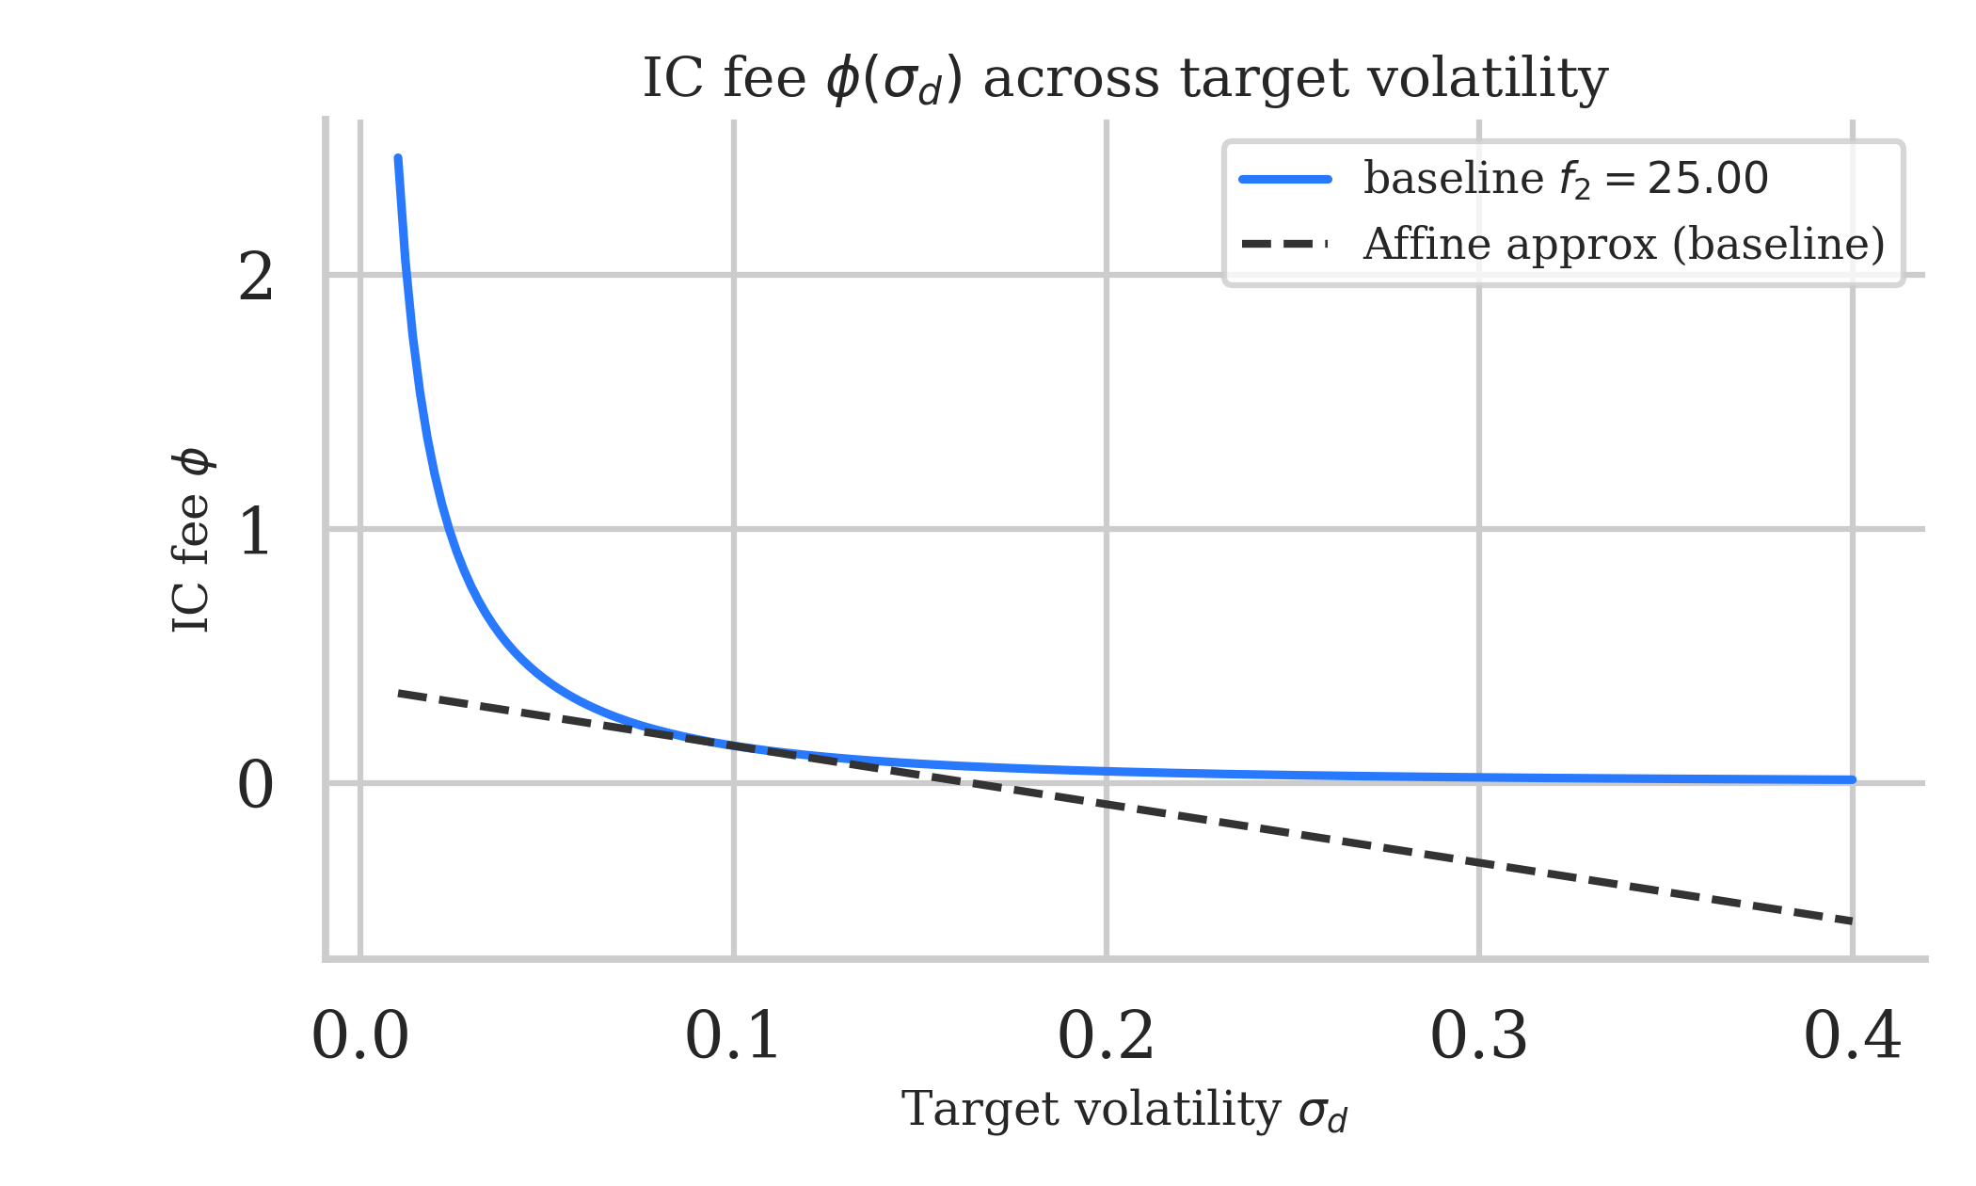
Note: Calibrated baseline parameters: $S=0.35$, $r_{f}=3.70\%$, $γ=5$, $η=3$, $A_{0}=1$, $f_{1}=1.5$, $f_{2}=25$.
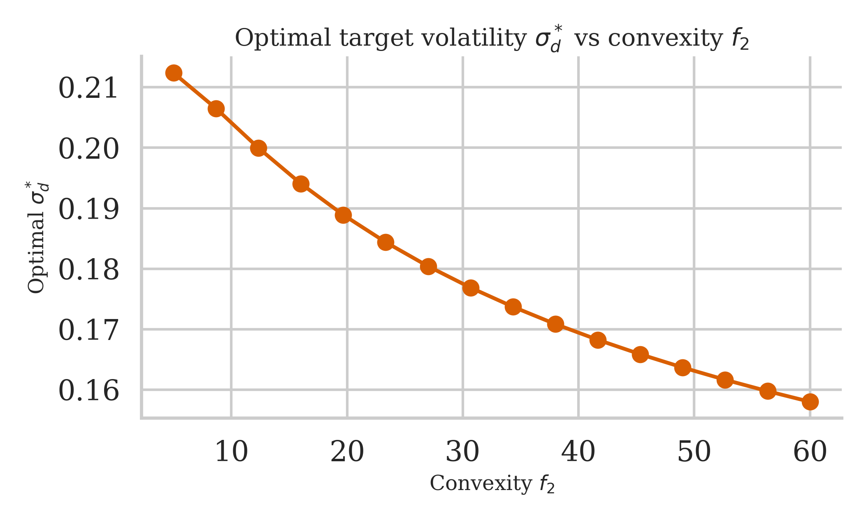
Note: Other parameters held at baseline: $S=0.5$, $r_{f}=2\%$, $γ=3$, $η=2$, $A_{0}=1$, $f_{1}=0.2$.
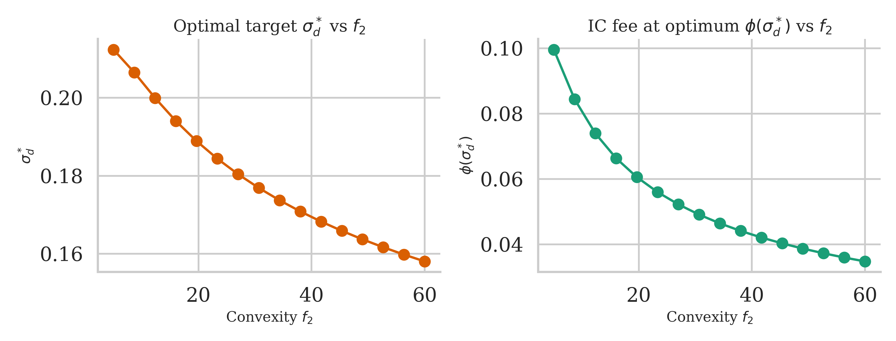
Note: Other parameters held at baseline: $S=0.5$, $r_{f}=2\%$, $γ=3$, $η=2$, $A_{0}=1$, $f_{1}=0.2$.
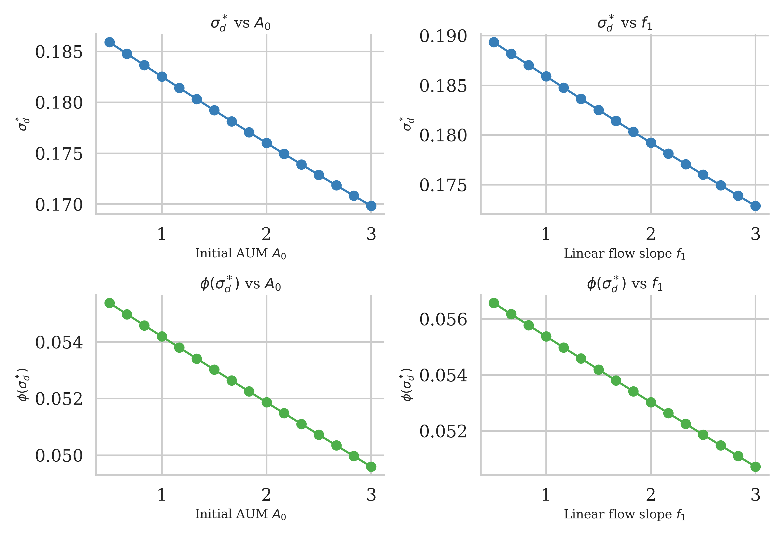
Note: Other parameters held at baseline: $S=0.5$, $r_{f}=2\%$, $γ=3$, $η=2$, $f_{2}=0.5$. Left panel varies $A_{0}$ with $f_{1}=0.2$; right panel varies $f_{1}$ with $A_{0}=1$.
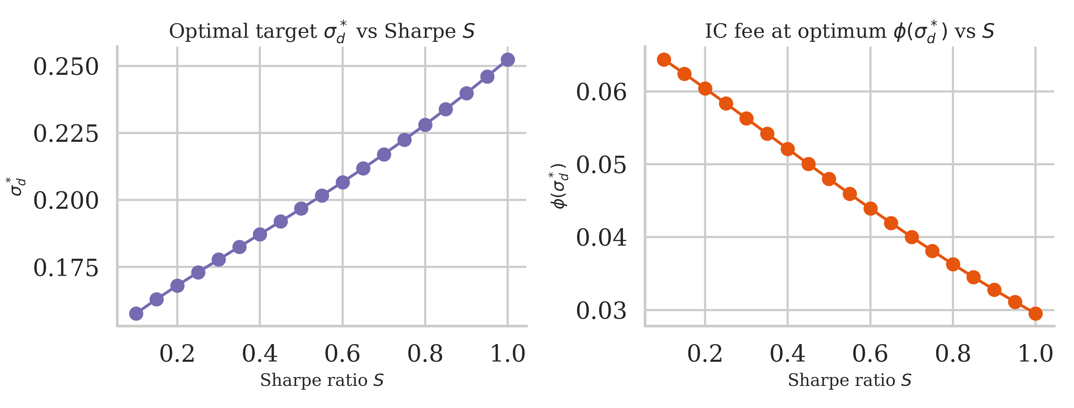
Note: Other parameters held at baseline: $r_{f}=2\%$, $γ=3$, $η=2$, $A_{0}=1$, $f_{1}=0.2$, $f_{2}=0.5$.
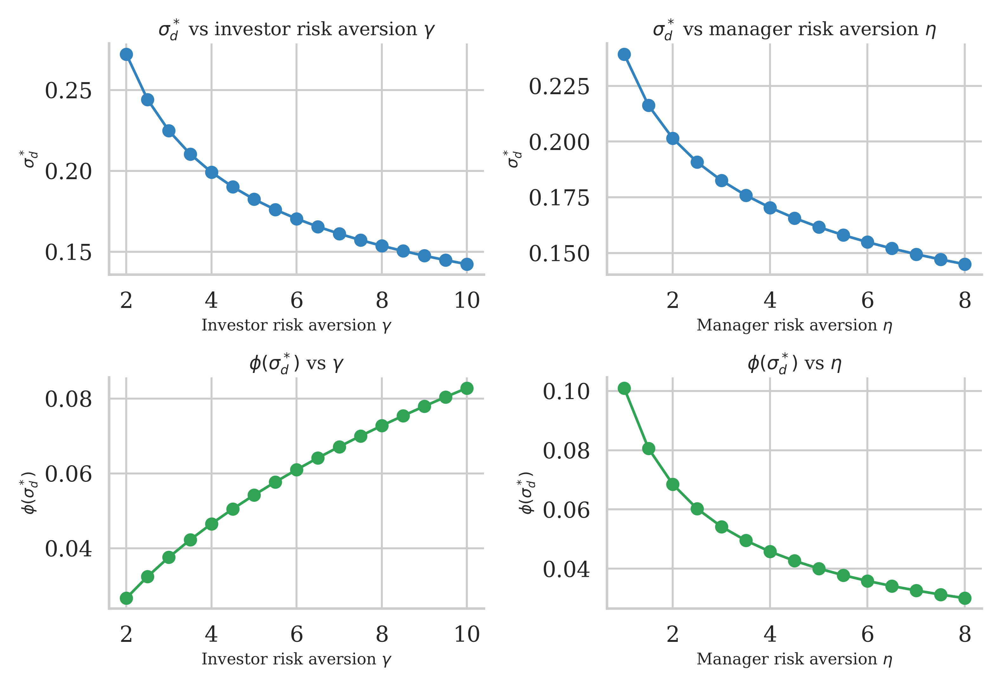
Note: Other parameters held at baseline: $S=0.5$, $r_{f}=2\%$, $A_{0}=1$, $f_{1}=0.2$, $f_{2}=0.5$. Left panel varies $γ$ with $η=2$; right panel varies $η$ with $γ=3$.
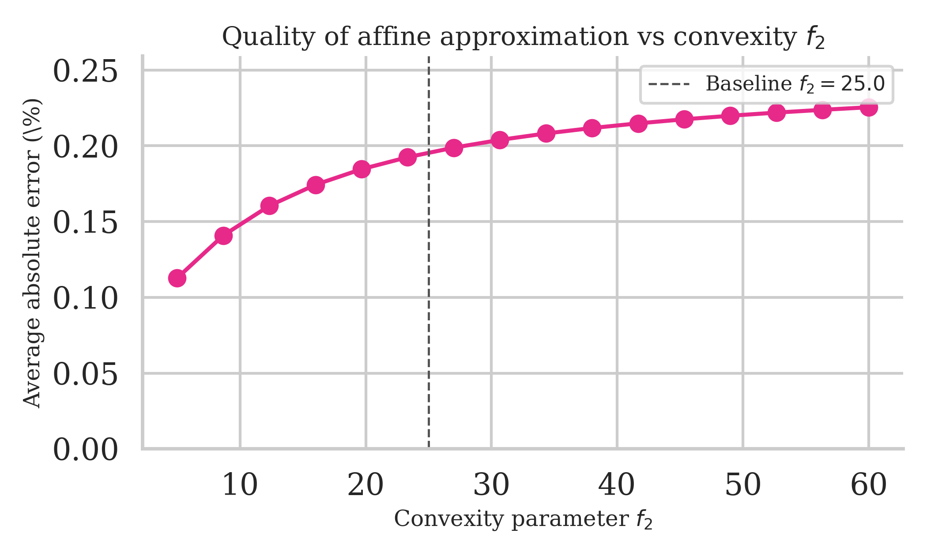
Note: Other parameters held at baseline: $S=0.5$, $r_{f}=2\%$, $γ=3$, $η=2$, $A_{0}=1$, $f_{1}=0.2$.

Appendices

A. Gaussian tail identities
Let $Z∼N(0,1)$ and $φ(z)$, $Φ(z)$ denote its pdf/cdf, where $φ(z)=\frac{1}{\sqrt{2π}}e^{-z^{2}/2}$ and $Φ(z)=\int_{-∞}^{z}{φ}(s) ds$. For any $a∈R$, we derive the following truncated moment formulas by integration by parts:
$$\begin{aligned}\int_{a}^{∞}{z} φ(z) dz&=φ(a), \\ \int_{a}^{∞}{z^{2}} φ(z) dz&=a φ(a)+1-Φ(a), \\ \int_{a}^{∞}{z^{3}} φ(z) dz&=(a^{2}+2) φ(a), \\ \int_{a}^{∞}{z^{4}} φ(z) dz&=(a^{3}+3a) φ(a)+3 (1-Φ(a)).\end{aligned}$$

A.1 Derivation sketch.
These identities follow from integration by parts using $φ^{'}(z)=-zφ(z)$. For [eq:tail1]: $\int_{a}^{∞}{z}φ(z)dz=-φ(z)|_{a}^{∞}=φ(a)$. For [eq:tail2]: write $z^{2}φ(z)=-z⋅φ^{'}(z)$ and integrate by parts to get $-zφ(z)|_{a}^{∞}+\int_{a}^{∞}{φ}(z)dz=aφ(a)+[1-Φ(a)]$. Higher moments follow recursively.

A.2 Application to our model.
Setting $a=-S$ and defining $X:=S+Z$, note that $\{X≥0\}=\{Z≥-S\}$. Therefore:
$$\begin{aligned}Pr[Z≥-S]&=Φ(S), \\ E[Z 1_{\{Z≥-S\}}]&=φ(S), \\ E[Z^{2} 1_{\{Z≥-S\}}]&=Φ(S)-S φ(S), \\ E[X^{2} 1_{\{X≥0\}}]&=(S^{2}+1) Φ(S)+S φ(S), \\ E[X^{3} 1_{\{X≥0\}}]&=(S^{3}+3S) Φ(S)+(S^{2}+2) φ(S), \\ E[X^{4} 1_{\{X≥0\}}]&=(S^{4}+6S^{2}+3) Φ(S)+(S^{3}+5S) φ(S).\end{aligned}$$
Lemma 1 (Useful tail moments with threshold $-S$). With $Z∼N(0,1)$, $X=S+Z$, and the indicator $1_{\{⋅\}}$:
$$\begin{aligned}Pr[Z≥-S]&=Φ(S),&E[Z 1_{\{Z≥-S\}}]&=φ(S), \\ E[Z^{2} 1_{\{Z≥-S\}}]&=Φ(S)-S φ(S),&E[X^{2} 1_{\{X≥0\}}]&=(S^{2}+1) Φ(S)+S φ(S).\end{aligned}$$

Appendix B: AUM moments, variance, and derivatives

Appendix B derives the moments of assets under management (AUM) and their derivatives with respect to volatility. These expressions underpin the manager’s optimization problem and the incentive-compatible contract discussed in the main text.

B1 Mean of AUM.
Using $E[X]=S$ and Appendix A for $E[X^{2}I]$, we obtain
$$\begin{aligned}E[A]&=A_{0}(1+r_{f})+K S σ+f_{2} σ^{2} C_{1}, \\ C_{1}&:=(S^{2}+1) Φ(S)+S φ(S).\end{aligned}$$

B2 Variance of AUM.
Since the constant term $A_{0}(1+r_{f})$ has zero variance, and writing $A-A_{0}(1+r_{f})=K σX+f_{2} σ^{2}X^{2}I$, we have
$$V[A]=V[K σX+f_{2} σ^{2}X^{2}I].$$
Using the variance formula $V[aU+bV]=a^{2}V[U]+b^{2}V[V]+2ab Cov(U,V)$ with $U=X$ and $V=X^{2}I$, and the fact that $V[X]=1$ since $X=S+Z$ with $Z∼N(0,1)$, we obtain
$$\begin{aligned}V[A]&=K^{2} σ^{2} V[X]+2 Kf_{2} σ^{3} Cov(X,X^{2}I)+f_{2}^{2} σ^{4} V(X^{2}I) \\ &=K^{2} σ^{2}+2 Kf_{2} σ^{3} Cov(X,X^{2}I)+f_{2}^{2} σ^{4} V(X^{2}I).\end{aligned}$$
Compute the cross and quadratic terms from Appendix A:
$$\begin{aligned}E[X^{2}I]&=C_{1}, E[X^{3}I]=(S^{3}+3S)Φ(S)+(S^{2}+2)φ(S), \\ E[X^{4}I]&=(S^{4}+6S^{2}+3)Φ(S)+(S^{3}+5S)φ(S).\end{aligned}$$
Hence, using the definition $Cov(U,V)=E[UV]-E[U]E[V]$ and noting that $E[X]=S$:
$$\begin{aligned}Cov(X,X^{2}I)&=E[X⋅X^{2}I]-E[X] E[X^{2}I] \\ &=E[X^{3}I]-S E[X^{2}I] \\ &=(S^{3}+3S)Φ(S)+(S^{2}+2)φ(S)-S C_{1}.\end{aligned}$$
Similarly, for the variance of $X^{2}I$:
$$\begin{aligned}V(X^{2}I)&=E[(X^{2}I)^{2}]-[E[X^{2}I]]^{2} \\ &=E[X^{4}I]-C_{1}^{2} \\ &=(S^{4}+6S^{2}+3)Φ(S)+(S^{3}+5S)φ(S)-C_{1}^{2}.\end{aligned}$$

B3 Derivatives in $σ$.
Differentiate with respect to $σ$:
$$\begin{aligned}∂_{σ}E[A]&=K S+2f_{2} σ C_{1}, \\ ∂_{σ}V[A]&=2K^{2}σ+6Kf_{2} σ^{2} Cov(X,X^{2}I)+4f_{2}^{2} σ^{3} V(X^{2}I).\end{aligned}$$
Define
$$Δ_{\text{quad}}(S,f_{2};σ):=6Kf_{2} σ^{2} Cov(X,X^{2}I)+4f_{2}^{2} σ^{3} V(X^{2}I),$$
so that $∂_{σ}V[A]=2K^{2}σ+Δ_{\text{quad}}(S,f_{2};σ)$.

Appendix C: Manager’s problem, best response, and IC fee
In this appendix we derive the manager’s first-order condition and the incentive-compatible fee schedule used in Section 2.3. The appendix shows how the manager’s optimal volatility choice depends on the marginal effect of volatility on expected AUM and AUM risk, and then derives the fee that implements a target volatility chosen by the investor.
C.1 Manager’s First-Order Condition
The manager’s objective is to maximize mean-variance utility over fee revenue $ϕA$:
$$\max_{σ} U_{M}(σ,ϕ)=ϕ E[A]-\frac{ηϕ^{2}}{2} V[A],$$
where $η>0$ is the manager’s risk aversion coefficient. Taking the first-order condition with respect to $σ$ and using the derivatives from [eq:dEA] and [eq:dVarA]:
$$\begin{aligned}\frac{∂U_{M}}{∂σ}&=ϕ ∂_{σ}E[A]-ηϕ^{2} ∂_{σ}V[A] \\ &=ϕ\left(KS+2f_{2} σ C_{1}\right)-ηϕ^{2}\left(2K^{2}σ+Δ_{\text{quad}}\right) \\ &=0.\end{aligned}$$
C.2 Existence and Uniqueness of the Manager’s Best Response
The left side represents the marginal net benefit of increasing volatility: the first term captures the increase in expected fee revenue (through both higher expected returns when $S>0$ and convex flow effects when $f_{2}>0$), while the second term captures the disutility associated with increased fee-revenue risk.
Under the condition that $ηϕ⋅2K^{2}>2f_{2}C_{1}$, the marginal cost grows faster than the marginal benefit for large values of σ. As a result, the first-order condition is strictly decreasing in σ, ensuring the existence of a unique interior solution σ∗(ϕ)>0

(ϕ)>0.the quadratic term $-ηϕ^{2}⋅2K^{2}σ$ dominates for large $σ$, making [eq:manager-FOC] a strictly decreasing function of $σ$. Since the FOC is positive at $σ=0$ (when $S>0$) and eventually negative for large $σ$, the intermediate value theorem guarantees a unique interior solution $σ^{*}(ϕ)>0$.

C.3 Closed-Form Approximation

To obtain additional analytical insight, it is useful to consider an approximation to the manager’s best response. Under the approximation
$$\frac{∂}{∂σ}Var(A)≈2K^{2}σ,$$
which captures the leading-order contribution of the linear term in AUM variance, the first-order condition simplifies.
Substituting this approximation into the first-order condition yields
$$ϕ(KS+2f_{2}σC_{1})-ηϕ^{2}(2K^{2}σ)=0.$$
Solving for $σ$, the manager’s best response admits the closed-form approximation
$$σ^{*}(ϕ)=\frac{KS}{2\left(ηϕK^{2} − f_{2}C_{1}\right)},$$
which is valid when $ηϕK^{2}>f_{2}C_{1}.$

C.4 Incentive Compatibility
Incentive compatibility requires that the manager’s first-order condition holds at the target volatility $σ=σ_{d}$. Imposing this condition yields
$$ϕ(σ_{d})=\frac{{\frac{∂}{∂σ}E[A]∣}_{σ_{d}}}{η{\frac{∂}{∂σ}Var(A)∣}_{σ_{d}}}.$$
Substituting the expressions for the derivatives derived in Appendix B, we obtain
$$ϕ(σ_{d})=\frac{KS+2f_{2}σ_{d}C_{1}}{η\left(2K^{2}σ_{d}+Δ_{\text{quad}}(S,f_{2};σ_{d})\right)}.$$
This expression characterizes the fee schedule that implements the desired volatility target $σ_{d}$ by equating the manager’s marginal benefit and marginal cost of risk-taking

Incentive compatibility requires the manager’s FOC to hold at $σ=σ_{d}$, yielding
$$ϕ(σ_{d}) = \frac{∂_{σ}E[A]|_{σ_{d}}}{η ∂_{σ}V[A]|_{σ_{d}}} = \frac{K S+2f_{2} σ_{d} C_{1}}{η\left(2K^{2} σ_{d}+Δ_{\text{quad}}(S,f_{2};σ_{d})\right)}.$$

Appendix D: Investor’s FOC and equilibrium condition
D.1 Investor’s First-Order Condition
With net returns $r^{\text{net}}=(1-ϕ)r-ϕ$ and investor utility
$$U_{I}(σ,ϕ)=E[r^{\text{net}}]-\frac{γ}{2}V[r^{\text{net}}]=(1-ϕ)(r_{f}+Sσ)-ϕ-\frac{γ}{2}(1-ϕ)^{2}σ^{2},$$
the investor chooses the target volatility $σ_{d}$ to maximize $U_{I}(σ_{d},ϕ(σ_{d}))$, where the fee $ϕ(σ_{d})$ is pinned down by the incentive compatibility constraint.
D.2 Equilibrium Characterization
For notational convenience, define
$\begin{aligned}N(σ)&:=K S + 2f_{2}σ C_{1}, \\ \\ \\ D(σ)&:=η\left(2K^{2}σ+Δ_{\text{quad}}(S,f_{2};σ)\right), \\ ϕ(σ)&:=\frac{N(σ)}{D(σ)}, ϕ^{'}(σ) = \frac{N^{'}(σ)D(σ)-N(σ)D^{'}(σ)}{D(σ)^{2}}.\end{aligned}$
where $N(σ)$ is the numerator and $D(σ)$ is the denominator of the IC fee [eq:phi-IC].
Substituting these expressions into the first-order condition yields a nonlinear equation in $σ$.
Define
$$G(σ):=(1-ϕ(σ))S-γ(1-ϕ\left(σ\right))^{2}σ+\left[-\left(r_{f}+Sσ\right)-1+γ\left(1-ϕ\left(σ\right)\right)σ^{2}\right]ϕ^{'}\left(σ\right).$$

The equilibrium target $σ_{d}^{*}$ is characterized by $G(σ_{d}^{*})=0$. This equation generally does not admit a closed-form solution and must be solved numerically, for example using bisection or Newton’s method.
D.3 Linear Approximation of the IC Fee
For practical implementation, we linearize the IC fee schedule around a reference volatility $σ_{0}$ (typically chosen as the optimal target $σ_{d}^{*}$).
Using a first-order Taylor approximation:
$ϕ(σ_{d}) ≈ ϕ(σ_{0})+ϕ^{'}(σ_{0})(σ_{d}-σ_{0})=\underset{α}{\underset{⏟}{[ϕ(σ_{0})-ϕ^{'}(σ_{0})σ_{0}]}}+\underset{β}{\underset{⏟}{ϕ^{'}(σ_{0})}} σ_{d},$
where $α:=ϕ\left(σ_{0}\right)-ϕ^{'}\left(σ_{0}\right) σ_{0},andβ:=ϕ^{'}(σ_{0}).$
The parameter $α$ acts as a base fee, while $β$ captures the marginal fee adjustment with respect to the volatility target.
This affine representation provides a transparent and practical implementation of the contract: once a volatility target is specified, the corresponding fee follows directly from a linear rule.
As shown in Figure 8, this approximation is highly accurate in the neighborhood of the optimal target, with small approximation errors over empirically relevant ranges.

Appendix E Fee base equivalence
Different fee conventions can be reconciled as follows. Suppose fees are charged on beginning-of-period AUM at rate $\tilde{ϕ}$, so the investor pays $\tilde{ϕ}A_{0}$ and receives terminal wealth $A_{0}(1+r)$, giving a net return per dollar invested of
$$r^{\text{net}}=\frac{A_{0}(1+r)-\tilde{ϕ}A_{0}}{A_{0}}=r-\tilde{ϕ}.$$
In the model, fees are charged on end-of-period AUM at rate $ϕ$, so the investor receives $(1-ϕ)A$ from terminal AUM $A=A_{0}(1+r)$, giving a net return of
$$r^{\text{net}}=\frac{(1-ϕ)A_{0}(1+r)}{A_{0}}=(1-ϕ)(1+r)-1=(1-ϕ)r-ϕ+O(ϕ^{2}).$$
Matching expected net returns to first order in fees:
$$E[r]-\tilde{ϕ}≈E[r]-ϕ(1+E[r]) ⇒ \tilde{ϕ}≈ϕ(1+r_{f}+Sσ).$$
For typical parameter values (e.g., $r_{f}=2\%$, $Sσ≈5\%-10\%$, $ϕ≈1\%-2\%$), the difference between conventions is second-order and negligible for practical purposes. Throughout the paper, we use the end-of-period convention as it aligns naturally with the flow-based AUM dynamics.

Appendix F : Performance fees with high–water marks (sketch)
Many hedge funds charge performance fees with high-water marks (HWM). A stylized HWM structure charges a performance fee $ψ(r-r_{f})^{+}$ on returns exceeding the risk-free rate (or previous peak). With fund return $r=r_{f}+σX$ where $X=S+Z$, this becomes
$$\text{Performance fee}=ψ⋅max(r-r_{f},0)=ψσ⋅max(X,0)=ψσX^{+}.$$
The manager’s expected fee revenue now includes this performance component. Using $X^{+}=X⋅1_{\{X≥0\}}$ and results from Appendix A:
$$E[X^{+}]=E[X⋅1_{\{X≥0\}}]=SΦ(S)+φ(S),$$
and higher moments follow similarly. Performance fees create additional convexity in the manager’s payoff, similar to the flow convexity $f_{2}$ but with different functional form. The key difference is that HWM fees are capped (cannot exceed the actual gain), whereas flow convexity can amplify AUM growth unboundedly in extreme positive scenarios.
Incorporating both management and performance fees into the framework requires computing $E[A]$ and $V[A]$ including the performance fee impact on net returns and flows. The IC condition becomes more complex but follows the same economic logic: the fee structure (now $ϕ$ and $ψ$) must be chosen to implement the desired volatility target. In practice, the equilibrium is computed numerically using the same bisection approach as in Appendix 10 ??, with the added complexity that the manager’s FOC now involves both fee components.

Appendix G: Numerical implementation notes

G.1 Solving for equilibrium.
To find the optimal target $σ_{d}^{*}$, solve $G(σ)=0$ where $G$ is defined in Section 10. We recommend bisection on an interval $[\underline{σ},\overline{σ}]$ where:
- $\underline{σ}>0$ is chosen small (e.g., $0.01$ or 1% annualized) to avoid numerical issues near zero.
- $\overline{σ}$ is chosen as an upper bound where the investor’s direct utility gain from volatility becomes negative. A conservative choice is to set $\overline{σ}$ such that $(1-ϕ)S-γ(1-ϕ)^{2}\overline{σ}<0$ when ignoring the contract adjustment term. For instance, with $ϕ≈0.02$, $S=0.5$, $γ=3$, this gives $\overline{σ}≈0.5/(3⋅0.98)≈0.17$. In practice, we use $\overline{σ}=0.40$ to be conservative.
Bisection is robust and converges rapidly since $G$ is continuous and typically has a unique zero in the relevant range.

G.2 Precomputing tail blocks.
For computational efficiency, precompute the Gaussian tail moments $Φ(S)$, $φ(S)$, $C_{1}$, $E[X^{3}I]$, and $E[X^{4}I]$ once for each Sharpe ratio $S$ using the formulas in Appendix A. These quantities depend only on $S$ (not on $σ$, $f_{2}$, etc.) and can be reused across all evaluations of $ϕ(σ)$ and $G(σ)$ for that value of $S$.

G.3 Parameter ranges.
The baseline parameter values for the numerical exercise are $S=0.5$, $r_{f}=0.02$, $γ=3$, $η=2$, $A_{0}=1$, $f_{1}=0.2$, $f_{2}=0.5$. Comparative statics sweep the following ranges:
- Convexity $f_{2}∈[0.02,0.25]$
- Initial AUM $A_{0}∈[0.5,3.0]$
- Linear flow $f_{1}∈[0.05,0.45]$
- Sharpe ratio $S∈[0.1,0.9]$
- Investor risk aversion $γ∈[1,8]$
- Manager risk aversion $η∈[0.5,6]$
These ranges cover empirically plausible scenarios while ensuring the FOCs remain well-behaved.

G.4 Affine approximation.
To construct the linear approximation $ϕ(σ_{d})≈α+βσ_{d}$, first solve for the optimal target $σ_{d}^{*}$, then compute $ϕ(σ_{d}^{*})$ and $ϕ^{'}(σ_{d}^{*})$ using the formulas in Sections 9 and 10. The approximation is then $α=ϕ(σ_{d}^{*})-βσ_{d}^{*}$ and $β=ϕ^{'}(σ_{d}^{*})$. As Figure 8 demonstrates, this approximation remains accurate within $±5\%$ of $σ_{d}^{*}$ with average errors around 0.1%.

REFERENCES
Admati, Anat R., and Paul Pfleiderer. 1997. “Does It All Add up? Benchmarks and the Compensation of Active Portfolio Managers.” The Journal of Business 70 (3): 323–50. https://doi.org/10.1086/209721.
Barras, Laurent, Olivier Scaillet, and Russ Wermers. 2010. “False Discoveries in Mutual Fund Performance: Measuring Luck in Estimated Alphas.” The Journal of Finance 65 (1): 179–216. https://doi.org/10.1111/j.1540-6261.2009.01527.x.
Bebchuk, Lucian A., Alma Cohen, and Scott Hirst. 2017. “The Agency Problems of Institutional Investors.” Journal of Economic Perspectives 31 (3): 89–102. https://doi.org/10.1257/jep.31.3.89.
Berk, Jonathan B, and Richard C Green. 2004. “Mutual Fund Flows and Performance in Rational Markets.” Journal of Political Economy 112 (6): 1269–95.
Brown, Keith C., W. Van Harlow, and Laura T. Starks. 1996. “Of Tournaments and Temptations: An Analysis of Managerial Incentives in the Mutual Fund Industry.” Journal of Finance 51 (1): 85–110. https://doi.org/10.1111/j.1540-6261.1996.tb05203.x.
Campbell, John Y., and Luis M. Viceira. 2002. Strategic Asset Allocation: Portfolio Choice for Long-Term Investors. Oxford University Press.
Carhart, Mark M. 1997. “On Persistence in Mutual Fund Performance.” The Journal of Finance 52 (1): 57–82. https://doi.org/10.1111/j.1540-6261.1997.tb03808.x.
Carhart, Mark M., Ron Kaniel, David K. Musto, and Adam V. Reed. 2002. “Leaning for the Tape: Evidence of Gaming Behavior in Equity Mutual Funds.” The Journal of Finance 57 (2): 661–93. https://doi.org/10.1111/1540-6261.00438.
Chevalier, Judith, and Glenn Ellison. 1997. “Risk Taking by Mutual Funds as a Response to Incentives.” Journal of Political Economy 105 (6): 1167–200.
Ferreira, Miguel A., Aneel Keswani, Antonio F. Miguel, and Sofia B. Ramos. 2012. “The Flow-Performance Relationship Around the World.” Journal of Banking & Finance 36 (6): 1759–80. https://doi.org/10.1016/j.jbankfin.2012.01.019.
Fung, William, and David A. Hsieh. 2004. “Hedge Fund Benchmarks: A Risk-Based Approach.” Financial Analysts Journal 60 (5): 65–80. https://doi.org/10.2469/faj.v60.n5.2657.
Gil-Bazo, Javier, and Pablo Ruiz-Verdú. 2008. “When Cheaper Is Better: Fee Determination in the Market for Equity Mutual Funds.” Journal of Economic Behavior & Organization 67 (3-4): 871–85. https://doi.org/10.1016/j.jebo.2007.04.003.
Guiso, Luigi, Paola Sapienza, and Luigi Zingales. 2018. “Time Varying Risk Aversion.” Journal of Financial Economics 128 (3): 403–21. https://doi.org/10.1016/j.jfineco.2018.02.007.
Holmström, Bengt. 1979. “Moral Hazard and Observability.” The Bell Journal of Economics 10 (1): 74–91. https://doi.org/10.2307/3003320.
Holmström, Bengt, and Paul Milgrom. 1987. “Aggregation and Linearity in the Provision of Intertemporal Incentives.” Econometrica 55 (2): 303–28. https://doi.org/10.2307/1913238.
Ippolito, Richard A. 1992. “Consumer Reaction to Measures of Poor Quality: Evidence from the Mutual Fund Industry.” Journal of Law and Economics 35 (1): 45–70. https://doi.org/10.1086/467244.
Jensen, Michael C., and William H. Meckling. 1976. “Theory of the Firm: Managerial Behavior, Agency Costs and Ownership Structure.” Journal of Financial Economics 3 (4): 305–60. https://doi.org/10.1016/0304-405X(76)90026-X.
Musto, David K. 1999. “Investment Decisions Depend on Portfolio Disclosures.” The Journal of Finance 54 (3): 935–52. https://doi.org/10.1111/0022-1082.00132.
Sirri, Erik R, and Peter Tufano. 1998. “Costly Search and Mutual Fund Flows.” Journal of Finance 53 (5): 1589–622.
Starks, Laura T. 1987. “Performance Incentive Fees: An Agency Theoretic Approach.” Journal of Financial and Quantitative Analysis 22 (1): 17–32. https://doi.org/10.2307/2330867.

To keep the model tractable, we ignore the risk of avalanche redemptions, which may take place when investors rush to exit funds as no investor desires to be the last to exit. Such behavior would introduce concavity in the flow-performance relation for negative excess returns.
We assume that investors do not have a minimum utility to achieve. In the presence of an outside option it is possible to add a reservation utility constraint $U_{I}\left(σ_{d},ϕ(σ_{d})\right)≥{\overset{‾}{U}}_{I}$
Source: FRED series DGS3MO, 2026-01-23: 3.70%. For euro-denominated settings, the ECB €STR (euro short-term rate) was approximately 1.93% as of the same date.
Specifically, $F(0.05)=1.5×0.05+25×{0.05}^{2}=0.1375$ and $F(0.10)=1.5×0.10+25×{0.10}^{2}=0.40$.

